# Very useful links.

(SORM3) Проблемы при отправке файлов
https://wiki.tcsbank.ru/pages/viewpage.action?pageId=270126634&refresh=1626432834233&focusedCommentId=295176019&refresh=1626433189317#comment-295176019

4.1.1 SORM
https://wiki.tcsbank.ru/display/INFRA/4.1.1+SORM
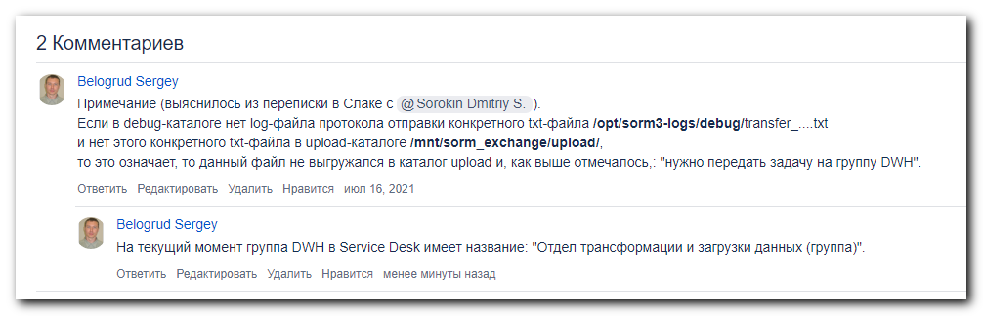

https://forge.tcsbank.ru/case/6069689/info
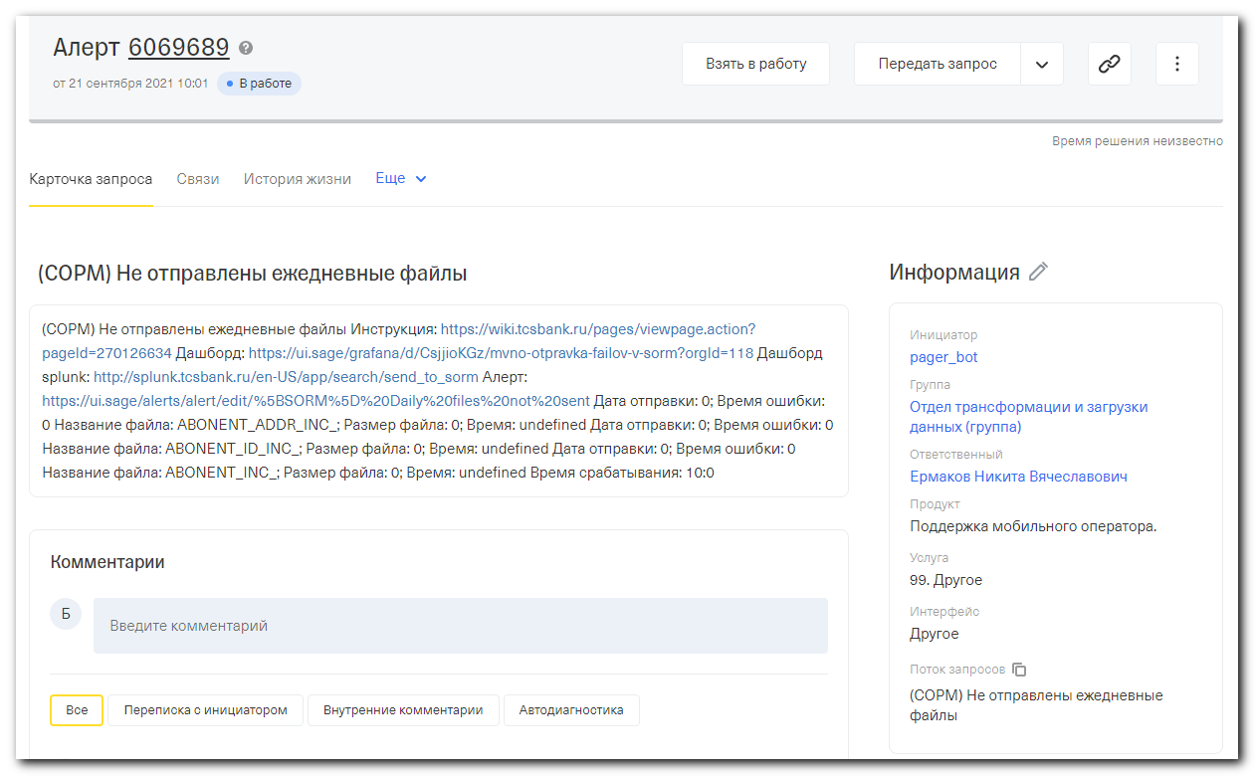
СОРМ) Не отправлены ежедневные файлы Инструкция: https://wiki.tcsbank.ru/pages/viewpage.action?pageId=270126634 Дашборд: https://ui.sage/grafana/d/CsjjioKGz/mvno-otpravka-failov-v-sorm?orgId=118 Дашборд splunk: http://splunk.tcsbank.ru/en-US/app/search/send_to_sorm Алерт: https://ui.sage/alerts/alert/edit/%5BSORM%5D%20Daily%20files%20not%20sent Дата отправки: 0; Время ошибки: 0 Название файла: ABONENT_ADDR_INC_; Размер файла: 0; Время: undefined Дата отправки: 0; Время ошибки: 0 Название файла: ABONENT_ID_INC_; Размер файла: 0; Время: undefined Дата отправки: 0; Время ошибки: 0 Название файла: ABONENT_INC_; Размер файла: 0; Время: undefined Время срабатывания: 10:0

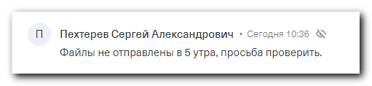

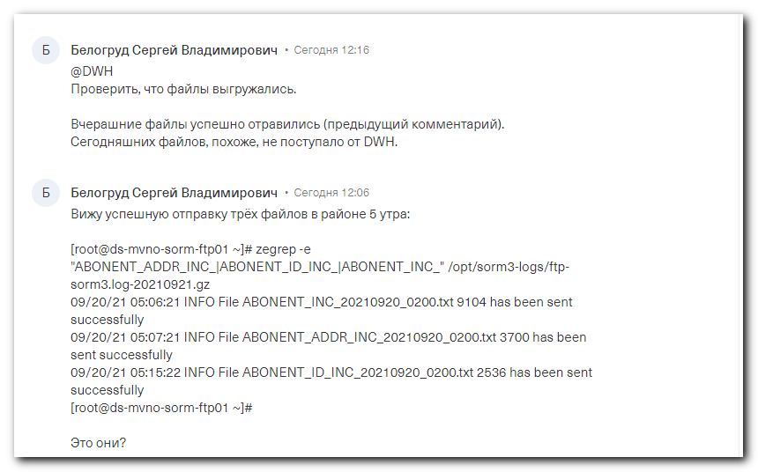

https://tinkoff.slack.com/archives/D02ENV1JB8X/p1632212545000300
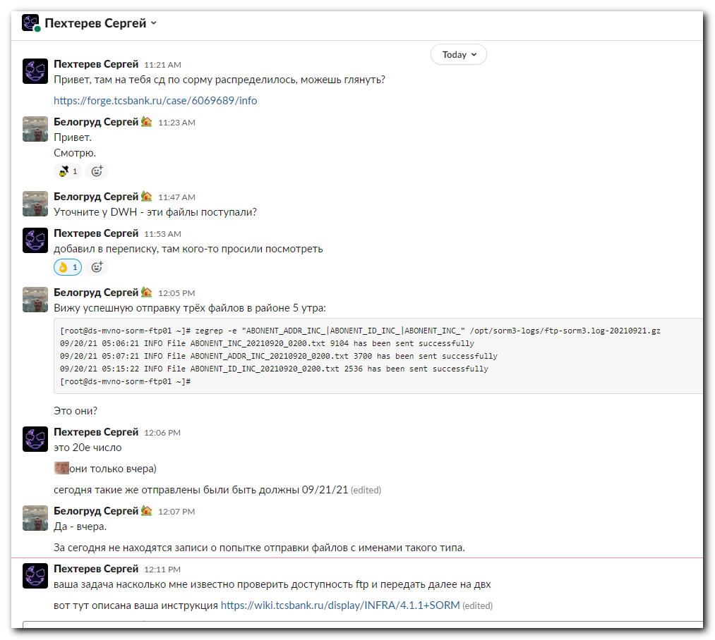
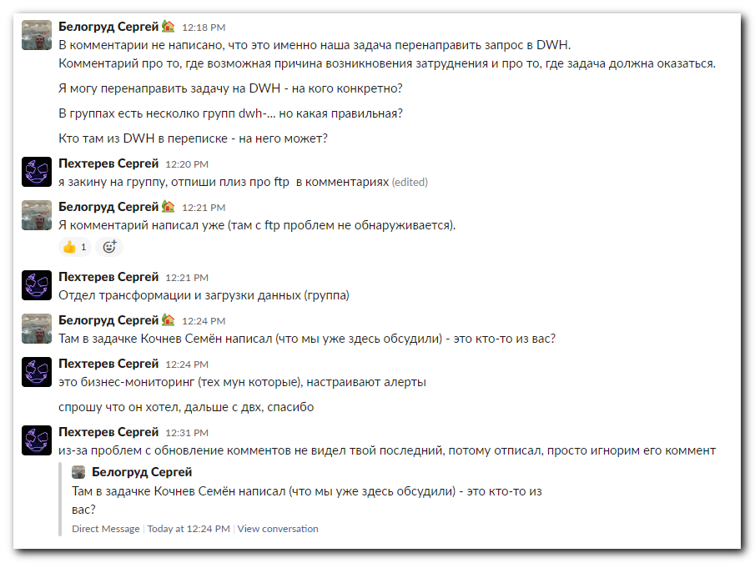

#
# Посмотрел в текущем журнале событий информацию об отправках или ошибках.
# Файлов с типом имени из задачи не нашлись.
#
[root@ds-mvno-sorm-ftp01 ~]# grep -e "^09/21/21 00:" /opt/sorm3-logs/ftp-sorm3.log | egrep -v -e "does not match any pattern|Already running with pid"
09/21/21 00:00:01 INFO Directory "/mnt/sorm_exchange/archive/2021/09/21" created sucesully.
09/21/21 00:02:22 INFO File CONNECTION_AAA_20210921_0000.txt 18032 has been sent successfully
09/21/21 00:02:42 INFO File ACCOUNT_BANK_PAYMENT_20210921_0000.txt 4 has been sent successfully
09/21/21 00:03:02 INFO File WITHDRAWALS_OTHER_PAYMENT_20210921_0000.txt 4 has been sent successfully
09/21/21 00:03:22 INFO File CONNECTION_GSM_20210921_0000.txt 8 has been sent successfully
09/21/21 00:03:42 INFO File PAYMENT_20210921_0000.txt 80 has been sent successfully
09/21/21 00:18:22 INFO File CONNECTION_AAA_20210921_0015.txt 19100 has been sent successfully
09/21/21 00:18:42 INFO File ACCOUNT_BANK_PAYMENT_20210921_0015.txt 4 has been sent successfully
09/21/21 00:19:02 INFO File WITHDRAWALS_OTHER_PAYMENT_20210921_0015.txt 4 has been sent successfully
09/21/21 00:19:22 INFO File CONNECTION_GSM_20210921_0015.txt 16 has been sent successfully
09/21/21 00:19:42 INFO File PAYMENT_20210921_0015.txt 120 has been sent successfully
09/21/21 00:32:21 INFO File CONNECTION_AAA_20210921_0030.txt 16888 has been sent successfully
09/21/21 00:32:41 INFO File ACCOUNT_BANK_PAYMENT_20210921_0030.txt 4 has been sent successfully
09/21/21 00:33:01 INFO File WITHDRAWALS_OTHER_PAYMENT_20210921_0030.txt 4 has been sent successfully
09/21/21 00:33:21 INFO File CONNECTION_GSM_20210921_0030.txt 16 has been sent successfully
09/21/21 00:33:41 INFO File PAYMENT_20210921_0030.txt 100 has been sent successfully
09/21/21 00:48:21 INFO File CONNECTION_AAA_20210921_0045.txt 16120 has been sent successfully
09/21/21 00:48:41 INFO File ACCOUNT_BANK_PAYMENT_20210921_0045.txt 4 has been sent successfully
09/21/21 00:49:01 INFO File WITHDRAWALS_OTHER_PAYMENT_20210921_0045.txt 4 has been sent successfully
09/21/21 00:49:21 INFO File CONNECTION_GSM_20210921_0045.txt 8 has been sent successfully
09/21/21 00:49:41 INFO File PAYMENT_20210921_0045.txt 60 has been sent successfully
[root@ds-mvno-sorm-ftp01 ~]#

#
# Посмотрел как называются сжатые файлы журналов за предыдущие дни.
#
[root@ds-mvno-sorm-ftp01 ~]# ls -1r /opt/sorm3-logs/ftp-sorm3.log-*.gz | head
/opt/sorm3-logs/ftp-sorm3.log-20210921.gz
/opt/sorm3-logs/ftp-sorm3.log-20210920.gz
/opt/sorm3-logs/ftp-sorm3.log-20210919.gz
/opt/sorm3-logs/ftp-sorm3.log-20210918.gz
/opt/sorm3-logs/ftp-sorm3.log-20210917.gz
/opt/sorm3-logs/ftp-sorm3.log-20210916.gz
/opt/sorm3-logs/ftp-sorm3.log-20210915.gz
/opt/sorm3-logs/ftp-sorm3.log-20210914.gz
/opt/sorm3-logs/ftp-sorm3.log-20210913.gz
/opt/sorm3-logs/ftp-sorm3.log-20210912.gz
[root@ds-mvno-sorm-ftp01 ~]#

#
# Date - yesterday.
# I checked info about same filename type, but on yesterday.
# I seen these files and they were sent correctly.
#
[root@ds-mvno-sorm-ftp01 ~]# zegrep -e "ABONENT_ADDR_INC_|ABONENT_ID_INC_|ABONENT_INC_" /opt/sorm3-logs/ftp-sorm3.log-20210921.gz
09/20/21 05:06:21 INFO File ABONENT_INC_20210920_0200.txt 9104 has been sent successfully
09/20/21 05:07:21 INFO File ABONENT_ADDR_INC_20210920_0200.txt 3700 has been sent successfully
09/20/21 05:15:22 INFO File ABONENT_ID_INC_20210920_0200.txt 2536 has been sent successfully
[root@ds-mvno-sorm-ftp01 ~]#

#
# Today - nothing.
#
[root@ds-mvno-sorm-ftp01 ~]# egrep -e "ABONENT_ADDR_INC_|ABONENT_ID_INC_|ABONENT_INC_" /opt/sorm3-logs/ftp-sorm3.log
[root@ds-mvno-sorm-ftp01 ~]#

# I used the link https://wiki.tcsbank.ru/display/INFRA/4.1.1+SORM and my last comment to understood - was these files uploaded from DWH or were not.
# There are no files in queue to upload. Files stucked and waiting for upload.
# These files were not uploaded from DWH.
#
[root@ds-mvno-sorm-ftp01 ~]# ls -Alh /mnt/sorm_exchange/upload/
total 0
[root@ds-mvno-sorm-ftp01 ~]

# Here are checks to be sure the files were not uploaded.
# Here are no today's log-files. That means the files were not uploaded from DWH.
#
[root@ds-mvno-sorm-ftp01 ~]# ls -Alht --time-style=long-iso /opt/sorm3-logs/debug/transfer_ABONENT_ADDR_INC_*
-rw------- 1 root root 2.9K 2021-09-20 05:07 /opt/sorm3-logs/debug/transfer_ABONENT_ADDR_INC_20210920_0200.txt
-rw------- 1 root root 3.0K 2021-09-19 05:14 /opt/sorm3-logs/debug/transfer_ABONENT_ADDR_INC_20210919_0200.txt
-rw------- 1 root root 3.0K 2021-09-18 05:05 /opt/sorm3-logs/debug/transfer_ABONENT_ADDR_INC_20210918_0200.txt
-rw------- 1 root root 3.0K 2021-09-17 05:07 /opt/sorm3-logs/debug/transfer_ABONENT_ADDR_INC_20210917_0200.txt
-rw------- 1 root root 3.0K 2021-09-16 15:55 /opt/sorm3-logs/debug/transfer_ABONENT_ADDR_INC_20210916_0200.txt
-rw------- 1 root root 2.9K 2021-09-15 05:06 /opt/sorm3-logs/debug/transfer_ABONENT_ADDR_INC_20210915_0200.txt
-rw------- 1 root root 3.0K 2021-09-14 05:05 /opt/sorm3-logs/debug/transfer_ABONENT_ADDR_INC_20210914_0200.txt
-rw------- 1 root root 3.0K 2021-09-13 05:06 /opt/sorm3-logs/debug/transfer_ABONENT_ADDR_INC_20210913_0200.txt
[root@ds-mvno-sorm-ftp01 ~]#

[root@ds-mvno-sorm-ftp01 ~]# ls -Alht --time-style=long-iso /opt/sorm3-logs/debug/transfer_ABONENT_ID_INC_*
-rw------- 1 root root 2.9K 2021-09-20 05:15 /opt/sorm3-logs/debug/transfer_ABONENT_ID_INC_20210920_0200.txt
-rw------- 1 root root 3.0K 2021-09-19 05:16 /opt/sorm3-logs/debug/transfer_ABONENT_ID_INC_20210919_0200.txt
-rw------- 1 root root 3.0K 2021-09-18 05:05 /opt/sorm3-logs/debug/transfer_ABONENT_ID_INC_20210918_0200.txt
-rw------- 1 root root 3.0K 2021-09-17 05:07 /opt/sorm3-logs/debug/transfer_ABONENT_ID_INC_20210917_0200.txt
-rw------- 1 root root 3.0K 2021-09-16 15:54 /opt/sorm3-logs/debug/transfer_ABONENT_ID_INC_20210916_0200.txt
-rw------- 1 root root 2.9K 2021-09-15 05:07 /opt/sorm3-logs/debug/transfer_ABONENT_ID_INC_20210915_0200.txt
-rw------- 1 root root 3.0K 2021-09-14 05:07 /opt/sorm3-logs/debug/transfer_ABONENT_ID_INC_20210914_0200.txt
-rw------- 1 root root 3.0K 2021-09-13 05:06 /opt/sorm3-logs/debug/transfer_ABONENT_ID_INC_20210913_0200.txt
[root@ds-mvno-sorm-ftp01 ~]#

[root@ds-mvno-sorm-ftp01 ~]# ls -Alht --time-style=long-iso /opt/sorm3-logs/debug/transfer_ABONENT_INC_*
-rw------- 1 root root 2.9K 2021-09-20 05:06 /opt/sorm3-logs/debug/transfer_ABONENT_INC_20210920_0200.txt
-rw------- 1 root root 3.0K 2021-09-19 05:14 /opt/sorm3-logs/debug/transfer_ABONENT_INC_20210919_0200.txt
-rw------- 1 root root 3.0K 2021-09-18 05:06 /opt/sorm3-logs/debug/transfer_ABONENT_INC_20210918_0200.txt
-rw------- 1 root root 3.0K 2021-09-17 05:08 /opt/sorm3-logs/debug/transfer_ABONENT_INC_20210917_0200.txt
-rw------- 1 root root 3.0K 2021-09-16 15:54 /opt/sorm3-logs/debug/transfer_ABONENT_INC_20210916_0200.txt
-rw------- 1 root root 2.9K 2021-09-15 05:06 /opt/sorm3-logs/debug/transfer_ABONENT_INC_20210915_0200.txt
-rw------- 1 root root 3.0K 2021-09-14 05:06 /opt/sorm3-logs/debug/transfer_ABONENT_INC_20210914_0200.txt
-rw------- 1 root root 3.0K 2021-09-13 05:05 /opt/sorm3-logs/debug/transfer_ABONENT_INC_20210913_0200.txt
[root@ds-mvno-sorm-ftp01 ~]#

-----Original Message-----
From: Ermakov Nikita <n.v.ermakov@tinkoff.ru>
Sent: Tuesday, September 21, 2021 2:33 PM
To: Pekhterev Sergey <s.pekhterev@tinkoff.ru>; Khaustova Ekaterina <e.khaustova@tinkoff.ru>; Kochenova Olga <o.kochenova@tinkoff.ru>; Rodionova Anastasiya <a.rodionova1@tinkoff.ru>; Kuznetsov Ivan K. <i.k.kuznetsov@tinkoff.ru>; Sizova Kseniya <k.sizova@tinkoff.ru>; Belogrud Sergey <s.belogrud@tinkoff.ru>
Cc: mvno_support <mvno_support@tinkoff.ru>
Subject: RE: (СОРМ) Не отправлены ежедневные файлы

Отправили

Ермаков Никита
Аналитик DWH MVNO
Группа системного анализа
Моб.:+7(910) 623-69-86

-----Original Message-----
From: Ermakov Nikita
Sent: Tuesday, September 21, 2021 11:56 AM
To: Pekhterev Sergey <s.pekhterev@tinkoff.ru>; Khaustova Ekaterina <e.khaustova@tinkoff.ru>; Kochenova Olga <o.kochenova@tinkoff.ru>; Rodionova Anastasiya <a.rodionova1@tinkoff.ru>; Kuznetsov Ivan K. <i.k.kuznetsov@tinkoff.ru>; Sizova Kseniya <k.sizova@tinkoff.ru>; Belogrud Sergey <s.belogrud@tinkoff.ru>
Cc: mvno_support <mvno_support@tinkoff.ru>
Subject: RE: (СОРМ) Не отправлены ежедневные файлы

Ночью нет, отгрузим в течение дня

Ермаков Никита
Аналитик DWH MVNO
Группа системного анализа
Моб.:+7(910) 623-69-86

-----Original Message-----
From: Pekhterev Sergey
Sent: Tuesday, September 21, 2021 11:53 AM
To: Khaustova Ekaterina <e.khaustova@tinkoff.ru>; Kochenova Olga <o.kochenova@tinkoff.ru>; Rodionova Anastasiya <a.rodionova1@tinkoff.ru>; Kuznetsov Ivan K. <i.k.kuznetsov@tinkoff.ru>; Ermakov Nikita <n.v.ermakov@tinkoff.ru>; Sizova Kseniya <k.sizova@tinkoff.ru>; Belogrud Sergey <s.belogrud@tinkoff.ru>
Cc: mvno_support <mvno_support@tinkoff.ru>
Subject: RE: (СОРМ) Не отправлены ежедневные файлы

Коллеги, юникс админы интересуются поступали ли файлы в DWH.
+ Belogrud Sergey

-----Original Message-----
From: Khaustova Ekaterina <e.khaustova@tinkoff.ru>
Sent: Tuesday, September 21, 2021 10:55 AM
To: Kochenova Olga <o.kochenova@tinkoff.ru>; Rodionova Anastasiya <a.rodionova1@tinkoff.ru>; Pekhterev Sergey <s.pekhterev@tinkoff.ru>; Kuznetsov Ivan K. <i.k.kuznetsov@tinkoff.ru>; Ermakov Nikita <n.v.ermakov@tinkoff.ru>; Sizova Kseniya <k.sizova@tinkoff.ru>
Cc: mvno_support <mvno_support@tinkoff.ru>
Subject: RE: (СОРМ) Не отправлены ежедневные файлы

+ Никита, Ксюша

________

Екатерина Хаустова
Старший аналитик

-----Original Message-----
From: Kochenova Olga
Sent: Tuesday, September 21, 2021 10:49 AM
To: Rodionova Anastasiya <a.rodionova1@tinkoff.ru>; Pekhterev Sergey <s.pekhterev@tinkoff.ru>; Kuznetsov Ivan K. <i.k.kuznetsov@tinkoff.ru>; Khaustova Ekaterina <e.khaustova@tinkoff.ru>
Cc: mvno_support <mvno_support@tinkoff.ru>
Subject: RE: (СОРМ) Не отправлены ежедневные файлы

+Иван, Катя DWH

-----Original Message-----
From: Rodionova Anastasiya
Sent: Tuesday, September 21, 2021 10:43 AM
To: Pekhterev Sergey <s.pekhterev@tinkoff.ru>; Kochenova Olga <o.kochenova@tinkoff.ru>
Cc: mvno_support <mvno_support@tinkoff.ru>
Subject: RE: (СОРМ) Не отправлены ежедневные файлы

Отправьте на net_admins для проверки сетевой доступности ftp МФИ Софт. При технической доступности и отсутствии сформированного файла со стороны DWH они перенаправят на нужную группу.

________

Анастасия Родионова
Куратор поддержки сервиса

-----Original Message-----
From: Pekhterev Sergey
Sent: Tuesday, September 21, 2021 10:42 AM
To: Kochenova Olga <o.kochenova@tinkoff.ru>
Cc: mvno_support <mvno_support@tinkoff.ru>
Subject: RE: (СОРМ) Не отправлены ежедневные файлы

Доброе утро.
Подскажите кто из DWH может проверить?

Пехтерев Сергей
Отдел поддержки сервисов

-----Original Message-----
From: svc_pager_bot <pager_bot@tinkoff.ru>
Sent: Tuesday, September 21, 2021 10:01 AM
To: mvno_support <mvno_support@tinkoff.ru>
Subject: (СОРМ) Не отправлены ежедневные файлы

(СОРМ) Не отправлены ежедневные файлы
Инструкция: https://wiki.tcsbank.ru/pages/viewpage.action?pageId=270126634
Дашборд: https://ui.sage/grafana/d/CsjjioKGz/mvno-otpravka-failov-v-sorm?orgId=118
Дашборд splunk: http://splunk.tcsbank.ru/en-US/app/search/send_to_sorm
Алерт: https://ui.sage/alerts/alert/edit/%5BSORM%5D%20Daily%20files%20not%20sent

Дата отправки: 0; Время ошибки: 0 Название файла: ABONENT_ADDR_INC_; Размер файла: 0; Время: undefined Дата отправки: 0; Время ошибки: 0 Название файла: ABONENT_ID_INC_; Размер файла: 0; Время: undefined Дата отправки: 0; Время ошибки: 0 Название файла: ABONENT_INC_; Размер файла: 0; Время: undefined

Время срабатывания: 10:0

